Bruteforcing the coupon code using burp suite.

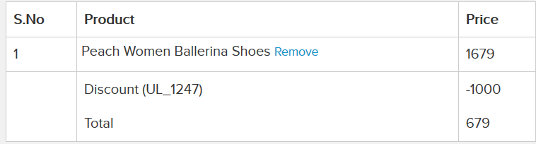

Guessing the admin credentials:

Username : admin

Password : admin

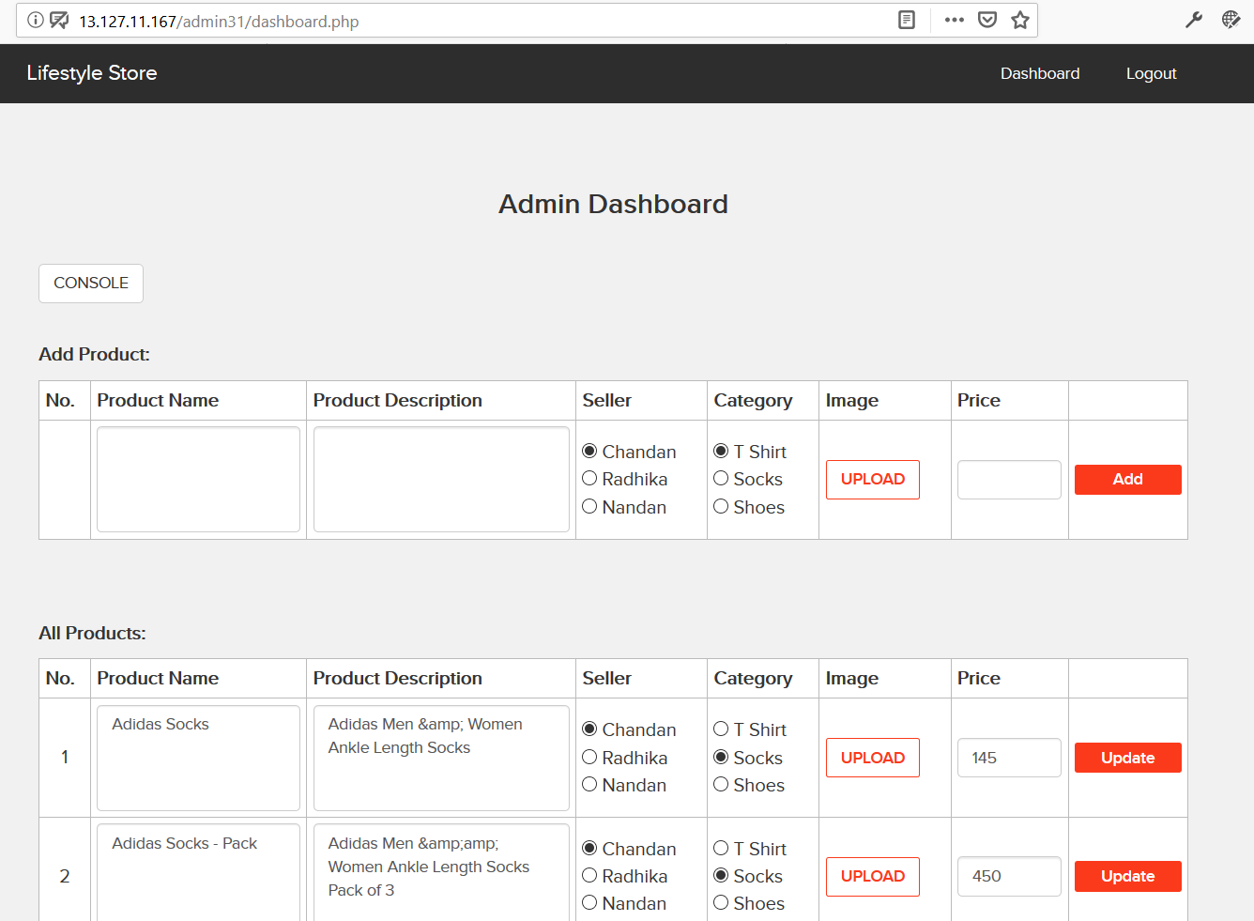

Also the Admin password can be reset by bruteforcing the otp validation.

